The Trail Rope
Gas Balloon Newsletter by Peter Cuneo & Barbara Fricke

Issue 5 June 2020
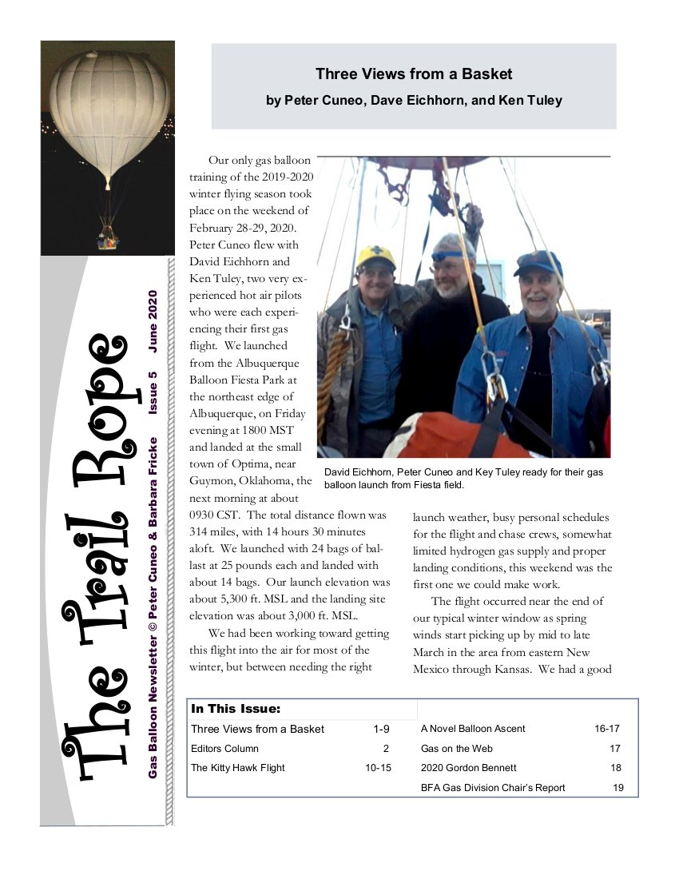The Trail Rope Issue 5 June 2020 - title page.
- Three Views from a Basket
- Editors Column
- The Kitty Hawk Flight
- A Novel Balloon Ascent
- Gas on the Web
- 2020 Gordon Bennett
- BFA Gas Division Chair’s Report
2020 June The Trail Rope Issue 5

Issue 4 January 2020
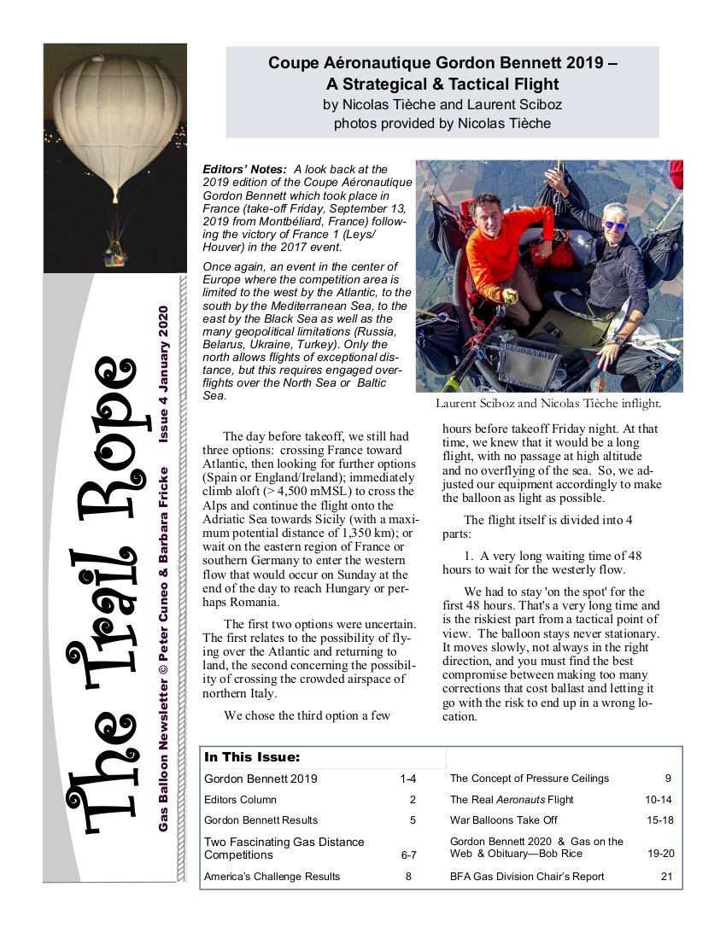The Trail Rope Issue 4 January 2020 - title page
- Gordon Bennett 2019
- The Concept of Pressure Ceilings
- Editors Column
- The Real Aeronauts Flight
- Gordon Bennett Results
- War Balloons Take Off
- Gordon Bennett 2020 & Gas on the Web & Obituary—Bob Rice
- Two Fascinating Gas Distance
- Competitions
- America’s Challenge Results
- BFA Gas Division Chair’s Report
2020 January The Trail Rope Issue 4
Tracedump:
newBaseSize: 11pt
newBaseSizeInPt: 11

