9th International Balloon Youth Camp in Wiehl
9th International Balloon Youth Camp
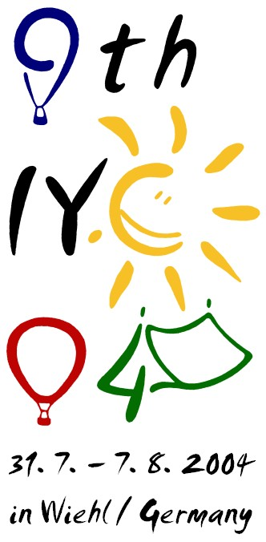Logo of the 9th International Youth Camp Ballooning
31.07.-07.08.2004
What do 44 youths from all over Europe have in common? Whenever they hear a horn hooting, they will have the inner longing to shout out “Briefing!” loudly. Sounds strange? But that's it!
After Kathrin Irion had resigned the year before, Sven Lüdecke and Matthias Schlegel agreed to carry on the tradition of the most famous and successful balloon youth camp.
This year's report was written by Martha Echle from Stuttgart. Thanks Martha, and to you, have fun reading!

1st day - Saturday, 31st July
On Saturday, July 31st, all the participants of the 9th International Youth Camp arrived in Wiehl, very much looking forward to the upcoming week. As foreign countries, Poland, Belgium, the Netherlands and Bavaria were represented.
After the “check in” where the rules were announced and a safety instruction for balloons took place, the boys and girls began to clean the bathrooms and make the camp site a home for the next seven days.
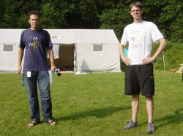Camp leaders Matthias Schlegel and Sven Lüdecke

2nd day - Sunday, 1st August
The second day began quite easy with waking at 8:30, filling out forms about oneself and playing ball games down in the park. After lunch everybody went to the swimming pool and in the evening we finally had the first balloon flight. We launched with seven balloons and everybody who wasn’t up in the air followed the balloons by car.
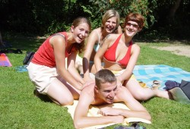The pilots really enjoyed their time in the camp ;-)

3rd day - Monday, 2nd August
On the third day we had to get up at 4:45 a.m. and took off with three balloons. After breakfast, a noon rest was called out, everybody was painting, drawing or sleeping. In the afternoon, Markus Pieper, the World Champion of hot air ballooning, visited us and was welcomed with applause and posters. As the weather was wonderful, the program was more or less the same like the day before with already daily water battles, cake in the afternoon and ballooning until late at night.
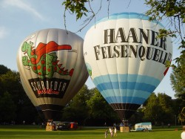The mineral spring »Haaner Felsenquelle« was one of the sponsors of the camp

4th day - Tuesday, 3rd August
The next day we were woken up again round 5 a.m. by “chief commander” Matthias Schlegel. One of the balloons starting had double size of our normal ones and for the evening flight, the local balloon pilots were prepared to take part with their balloons, so that we had twelve balloons in the air that evening. Among these pilots was also World Champion Markus Pieper with his competition balloon.
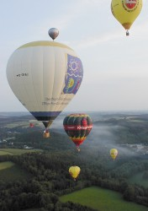One of the highlights was an evening flight with 12 balloons

5th day - Wednesday, 4th August
The 5th day we finally were allowed to sleep in but a few crazy volunteers got up nevertheless to take a flight. Afterwards most of the participants drew the logo of the camp on white t-shirts and in the afternoon, we took the cars to Oberhausen to visit the exhibition of the round-the-world-balloon Breitling Orbiter 3.
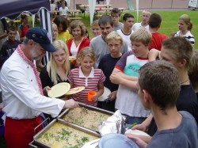JoWilli Wagner of the local balloon club was a great help with cooking

6th day - Thursday, 5th August
On Thursday almost everybody went to Cologne, some went to the Chocolate Museum, the others went shopping. In the evening, Tomas Hora showed a presentation about one of his adventures with the gas balloon.
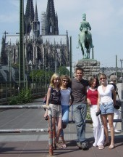A day in Cologne was also on our schedule.

7th day - Friday, 6th August
Friday began with yet another morning flight, the last flight of the camp. After cleaning the camp site and the cars, the preparings for the party in the evening began. We had a great barbecue with the local balloon club and the free beer kept us up until late at night. Several competitions and nominations (e.g. the nomination of the “Sexiest Boy 04”) took place to entertain us.
The next morning and last day began quite early as everything had to be sorted out, packed, cleaned… All in all we had a wonderful week together, exhausting, exciting, wet and with lots of fun.
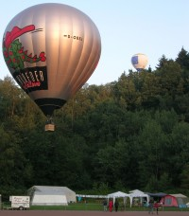The Youth's Balloon from SCHROEDER fire balloons over the campsite

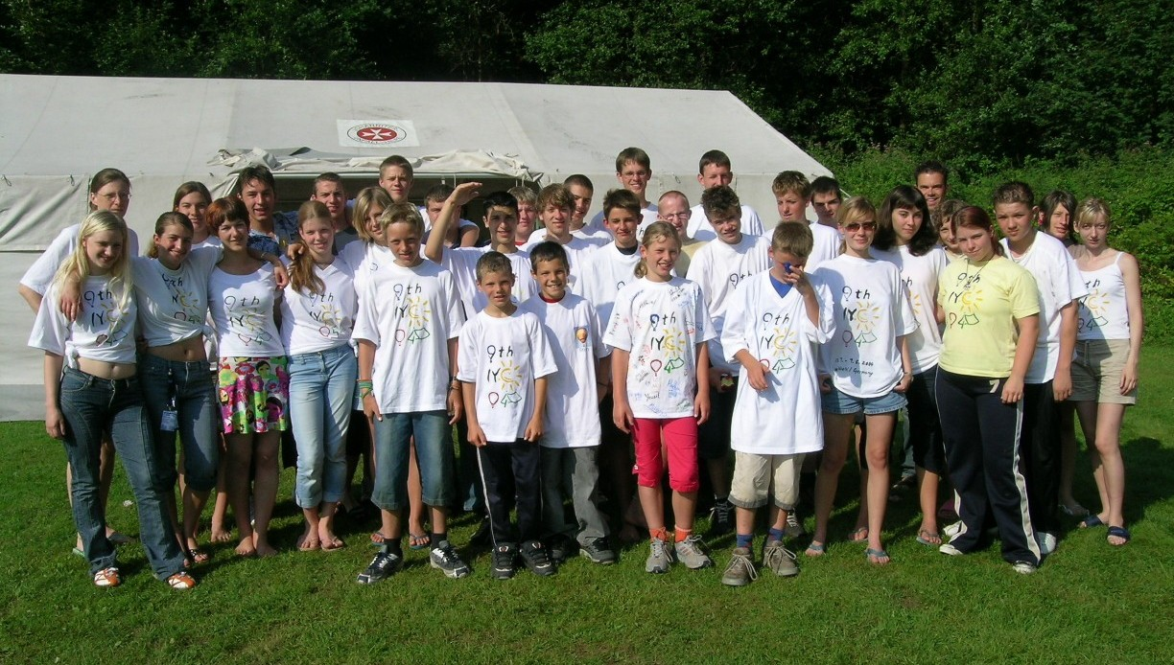The 44 participants of the 9th IYC 04 came from 4 different nations. Click to enlarge!
We are very grateful for all the sponsors, the local balloon club, the camp leaders and all the others who made such a great time possible. Looking forward to next year very much we say good bye for now and wish everybody a good and relaxing time until then.
Martha Echle
Tracedump:
newBaseSize: 11pt
newBaseSizeInPt: 11

