Carabiner
Karabiner Mousqueton
Carabiners are used to connect ropes. For a carabiner, also the expression snap-hook is possible. A longer description is published at Wikipedia: Carabiner
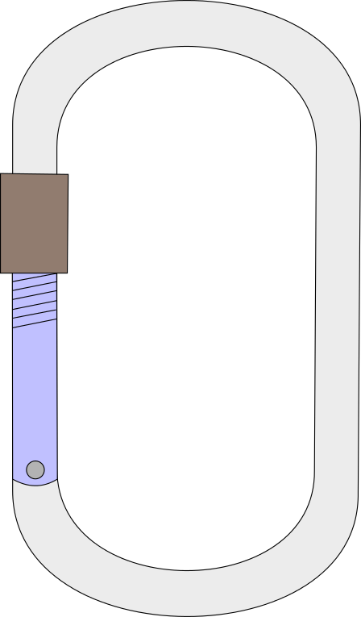Carabiner
Tracedump:
newBaseSize: 11pt
newBaseSizeInPt: 11

